**C program to identify whether a given line is a comment or not?**

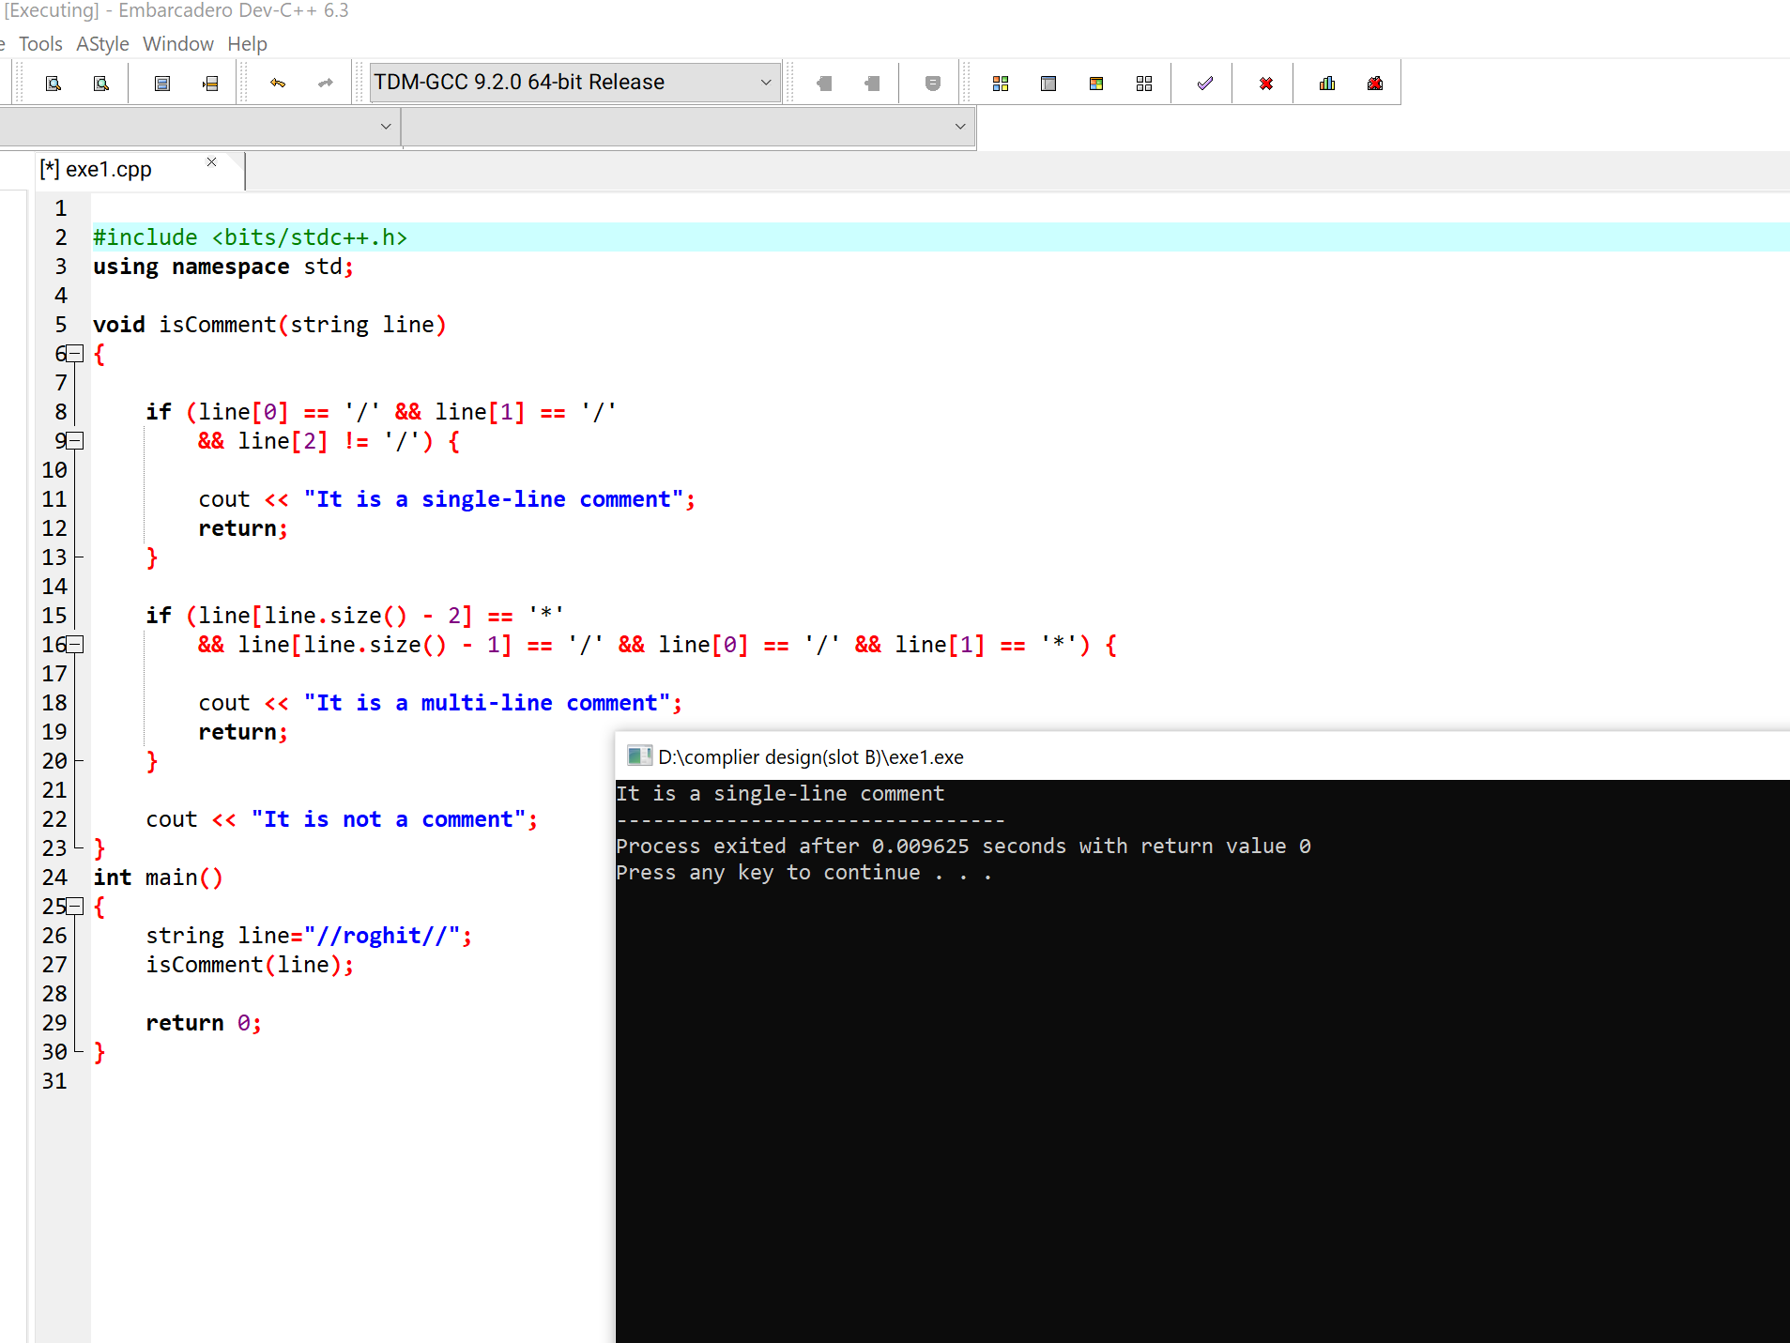

**C program to test whether a given identifier is valid or not?**

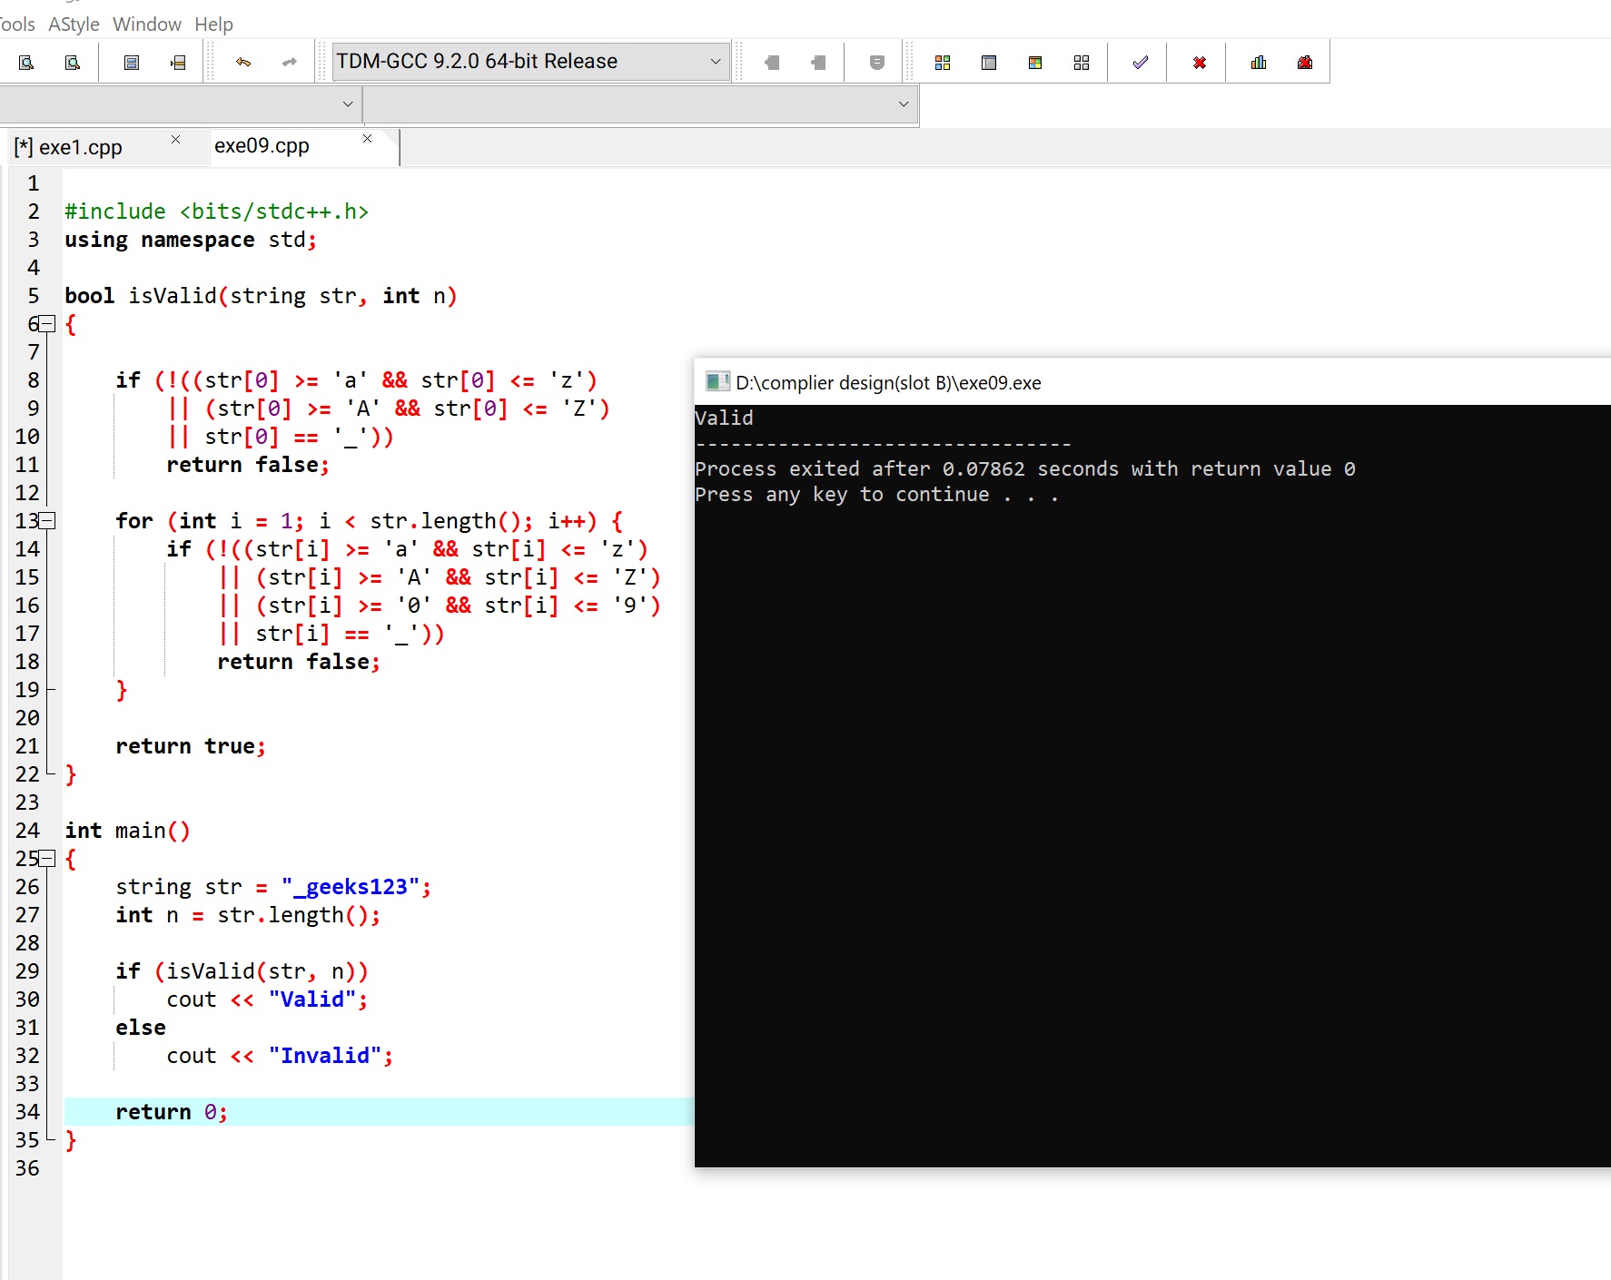

**Develop a lexical analysis to identify identifiers, constants, operators using C program.**

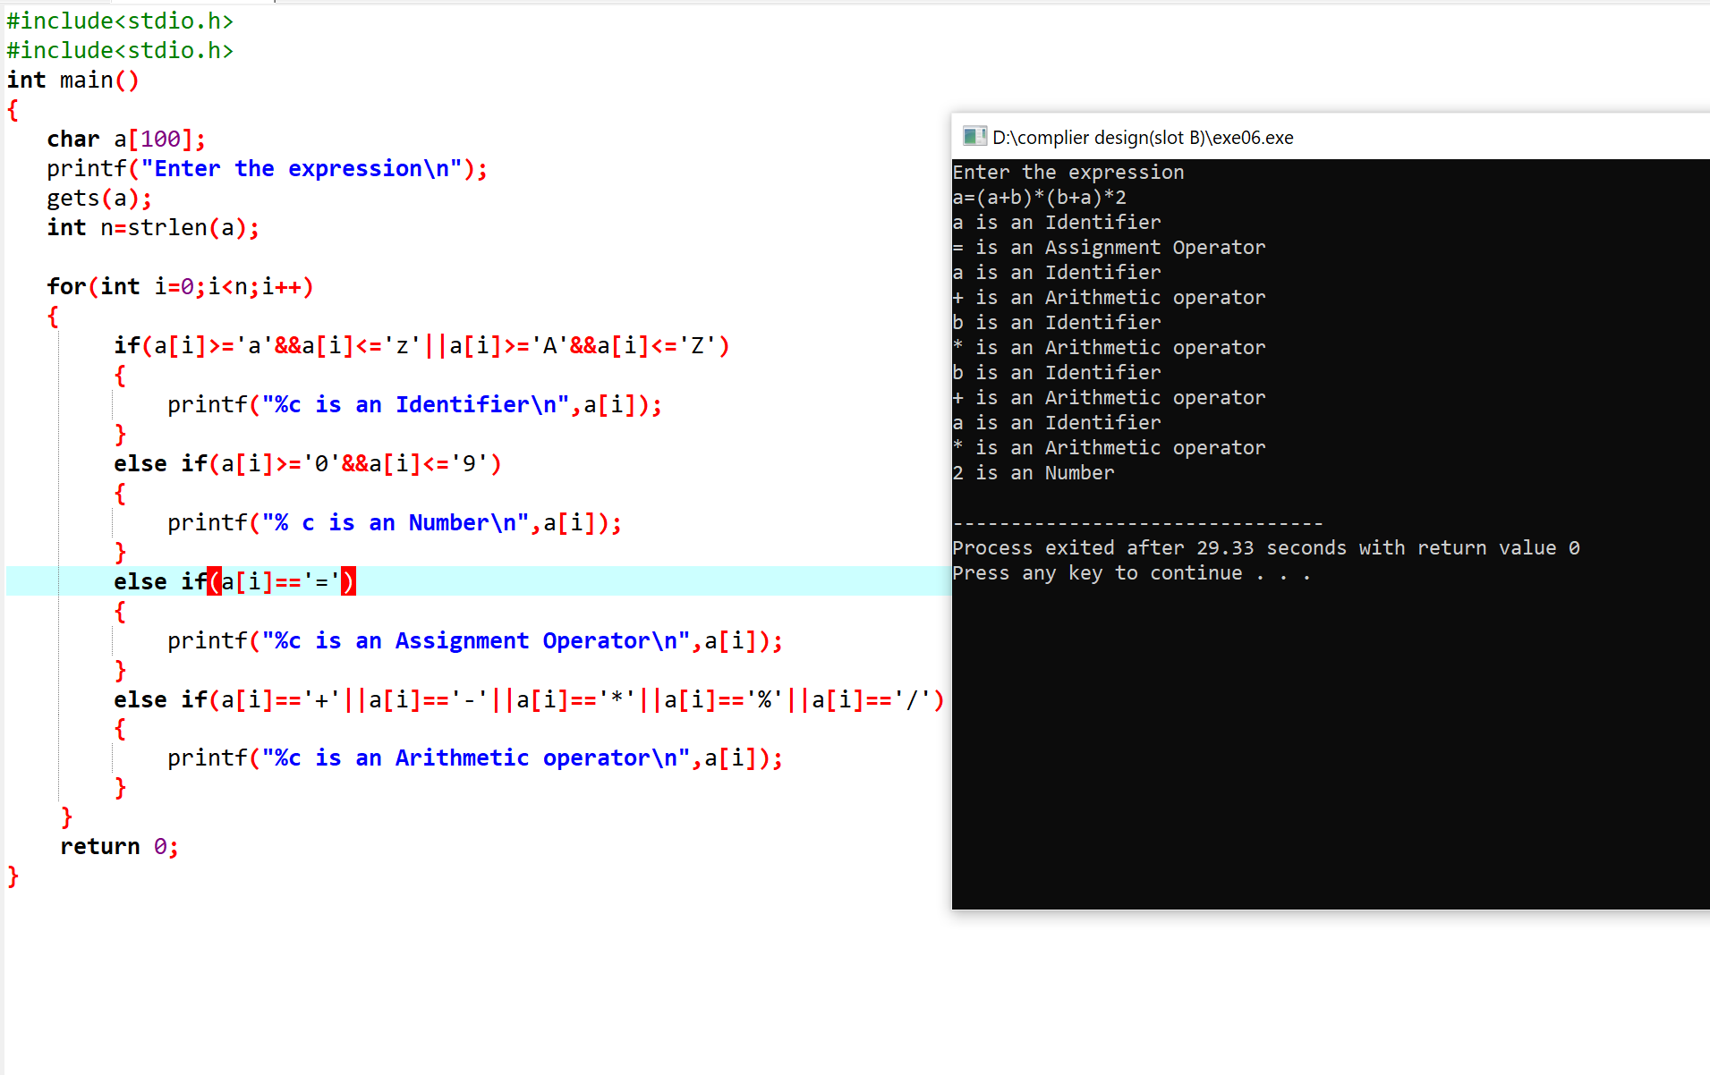

**C program to find FIRST and FOLLOW for predictive parser?**

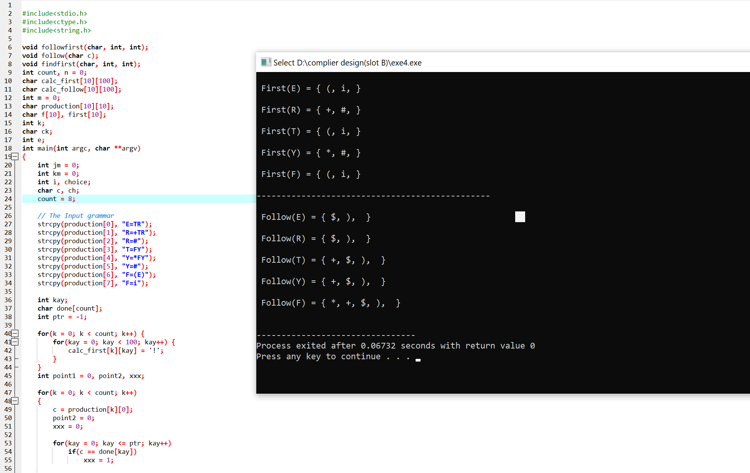

**Implement a C program to eliminate left recursion and left factoring from a given CFG.**

